Week 3 Lecture Notes
1.7 Linear and Quadratic Approximations
In optimization, the quadratic (second-order) approximation of a function is often preferred because certain solution methods, such as Newton’s method, exhibit faster convergence for functions of this type. As discussed in a previous section, the Taylor series expansion can be used to obtain the linear or quadratic approximation of a function by appropriately selecting the number of terms included in the series.
To demonstrate the linear and quadratic approximations of the function $e^{-x}$, a MATLAB code named quadr.m was written (Figure 1.16).
The Taylor series expansion can be easily extended to a function of $n$variables and can be expressed as follows:
$$f(x+Δx)=f(x)+∇f(x)^{T}Δx+\frac{1}{2} Δx^{T}HΔx+⋯ (1.50)$$
For the linear approximation of a function, only the gradient term is used, and the Hessian term is neglected. For the quadratic approximation, the Hessian term is taken into account in addition to the gradient term.
As in Example 1.2, for a function of two variables, a MATLAB code named quadr_examp12.m was written to obtain the quadratic approximation of the function. When the code is executed, the quadratic approximations of the function are plotted together with its contour curves (Figure 1.17).
For this function, the gradient and the Hessian are given as follows:
$$∇f\left(x\right)=\left[\begin{aligned}2x_{1}+4x_{2} \\ 4x_{1}+2x_{2}\end{aligned}\right] (1.51)$$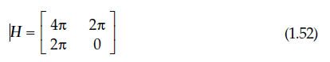
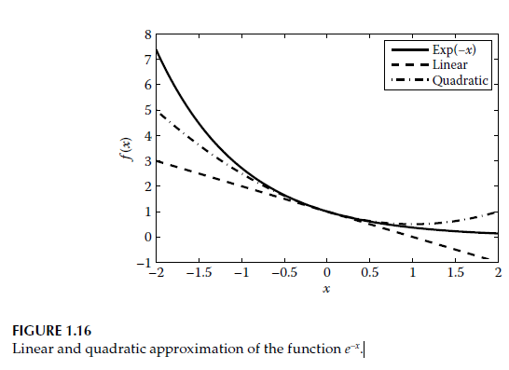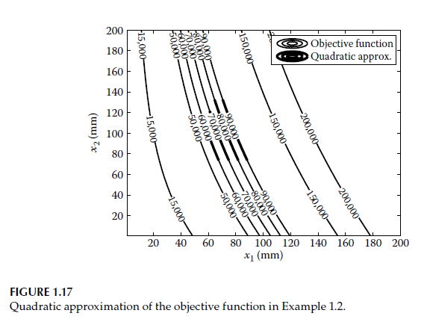

Example 1.6
For the following function, construct the linear and quadratic approximations at the point (2, 1):
$$f(x)=3x_{2}-\frac{x_{1}}{x_{2}}$$
Point:
$$x_{0}=(2,1)$$Fuction value
$$f(2,1)=3(1)-\frac{2}{1} \\ =3-2=1$$Gradient Calculation (Step by Step)
🔹 ∂f/∂x₁
Function:
$$f=3x_{2}-\frac{x_{1}}{x_{2}}$$We take the derivative with respect to $x_{1}$.
- $3x_{2}$→ constant (does not contain $x_{1}$) → derivative is 0
- $-\frac{x_{1}}{x_{2}}$→ $x_{2}$is treated as a constant.
$$\frac{∂f}{∂x_{1}}=-\frac{1}{x_{2}}$$∂f/∂x₂
Önce şu şekilde yazalım: $\frac{x_{1}}{x_{2}}=x_{1}x_{2}^{-1}$=$\frac{d}{dx_{2}}(x_{2}^{-1})=-1x_{2}^{-2}$
Bu yüzden:
$$\frac{∂f}{∂x_{2}}=3-(-\frac{x_{1}}{x_{2}^{2}}) \\ =3+\frac{x_{1}}{x_{2}^{2}}$$
Gradyan:
$$∇f(x)=\left[\begin{aligned}-\frac{1}{x_{2}} \\ 3+\frac{x_{1}}{x_{2}^{2}}\end{aligned}\right]$$Let us evaluate it at the point (2, 1).
$$∇f(2,1)=\left[\begin{aligned}-1 \\ 3+\frac{2}{1^{2}}\end{aligned}\right]=\left[\begin{aligned}-1 \\ 5\end{aligned}\right]$$
Hessian Hesabı
Hessian = ikinci türev matrisi.
∂²f/∂x₁²
$$\frac{∂}{∂x_{1}}\left(0 − \frac{1}{x_{2}}\right)=0$$
Because it depends on $x_{2}$. We need the derivative with respect to $x_{1}$.
∂²f/∂x₁∂x₂
$$\frac{∂}{∂x_{2}}\left(0 − \frac{1}{x_{2}}\right) \\ =-(-1)x_{2}^{-2}=\frac{1}{x_{2}^{2}}$$ ∂²f/∂x₂²
Start:
$$\frac{∂f}{∂x_{2}}=3+\frac{x_{1}}{x_{2}^{2}}$$
Derivate:
$$\frac{∂^{2}f}{∂x_{2}^{2}}=x_{1}(-2)x_{2}^{-3}=-\frac{2x_{1}}{x_{2}^{3}}$$
✅ Hessian
$$H=\left[\begin{matrix}0 & \frac{1}{x_{2}^{2}} \\ \frac{1}{x_{2}^{2}} & -\frac{2x_{1}}{x_{2}^{3}}\end{matrix}\right]$$(2,1) noktasında
$$H(2,1)=\left[\begin{matrix}0 & 1 \\ 1 & -4\end{matrix}\right]$$
Linear Approximation
Formül:
$$l(x)=f(x_{0})+∇f(x_{0})^{T}(x-x_{0}) \\ =1+[-1 5]\left[\begin{aligned}x_{1}-2 \\ x_{2}-1\end{aligned}\right]$$
Çarpım:
$$=-1(x_{1}-2)+5(x_{2}-1) \\ =-x_{1}+2+5x_{2}-5 \\ =-x_{1}+5x_{2}-3$$
Sonra +1 ekliyoruz:
$$\boxed{l(x)=-x_{1}+5x_{2}-2}$$
Quadratic Approximation
Formül:
$$q(x)=l(x)+\frac{1}{2}(x-x_{0})^{T}H(x-x_{0})$$

First:
$$(x-x_{0})=\left[\begin{aligned}x_{1}-2 \\ x_{2}-1\end{aligned}\right]$$
Now the quadratic form:
$$\left[\begin{matrix}x_{1}-2 & x_{2}-1\end{matrix}\right]\left[\begin{matrix}0 & 1 \\ 1 & -4\end{matrix}\right]\left[\begin{aligned}x_{1}-2 \\ x_{2}-1\end{aligned}\right]$$
First, perform the matrix multiplication:
$$=\left[\begin{aligned}\left(x_{2} − 1\right) \\ \left(x_{1}-2)-4(x_{2}-1\right)\end{aligned}\right]$$
Now multiply by the left vector:
$$=(x_{1}-2)(x_{2}-1)+(x_{2}-1)((x_{1}-2)-4(x_{2}-1)) \\ =2(x_{1}-2)(x_{2}-1)-4(x_{2}-1)^{2}$$
Now multiply by $\frac{1}{2}$:
$$=(x_{1}-2)(x_{2}-1)-2(x_{2}-1)^{2}$$
✅ Final Result
$$q(x)=-x_{1}+5x_{2}-2+(x_{1}-2)(x_{2}-1)-2(x_{2}-1)^{2}$$
NOTE:
The answer in the book is mathematically identical; however:
- The rational derivative expressions were not simplified.
- The $\left(x_{2} − 1\right)$factors were not expanded.
- The value $x_{2}=1$was not substituted into the Hessian terms.
Therefore, it looks different. But the results are completely correct.

2. Optimizasyon Algoritmaları

2.1. Introduction
A one-dimensional (1-D) optimization problem refers to an objective function with a single variable. In practice, multivariable optimization problems are generally complex, and single-variable problems are rarely encountered. Nevertheless, one-dimensional optimization algorithms form the fundamental building blocks of multivariable algorithms. Since these algorithms appear as subproblems within multivariable optimization problems, numerous methods (or algorithms) have been developed in the literature, each having certain unique advantages over the others.
These algorithms are generally classified as gradient-based and non-gradient-based algorithms.
As an example, a single-variable objective function may be given as:
$$f(x)=2x^{2}-2x+8$$
This represents an unconstrained optimization problem, where the objective is to determine $x$such that $f(x)$is minimized.
If the variable $x$is restricted as
$$a≤x≤b$$
where $a$and $b$are real numbers, the problem becomes a constrained optimization problem.
Another important point is that if the function $f(x)$exhibits a continuously increasing or decreasing behavior between the points $a$and $b$, it is called a monotonic function (see Figure 2.1).
In a unimodal function, however, the function shows monotonic behavior on both sides of the minimum point $x^{*}$. That is, the function continues increasing or decreasing consistently on both the right and left sides of the minimum point.
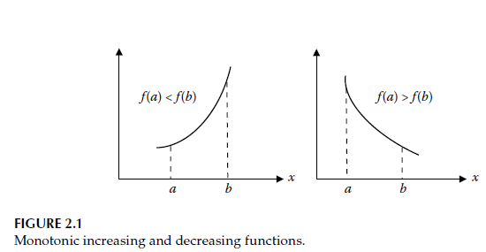
For example, the function $f(x)=2x^{2}-2x+8$ is plotted in Figure 2.2, and from this graph it can be seen that $f(x)$is a unimodal function.
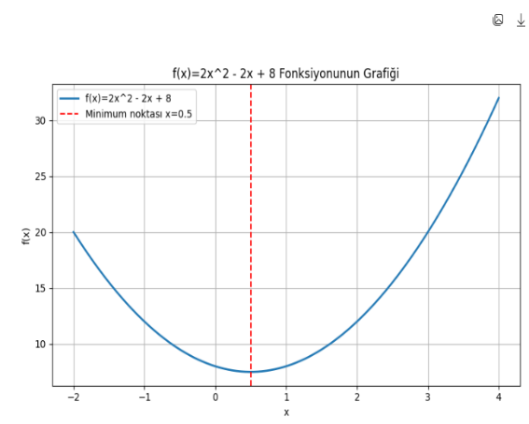
.By using the property that unimodal functions exhibit a continuously increasing or decreasing structure on both sides of the minimum point, one-dimensional search algorithms can be designed to systematically eliminate regions where the minimum does not exist.
To find the minimum of the function
$$f(x)=2x^{2}-2x+8$$

we take the derivative and set it equal to zero. This is because minimum, maximum, or inflection (slope-change) points can only occur where the derivative is zero.
$$f^{'}(x)=4x-2=0⇒x^{*}=\frac{1}{2}$$
Left side of the minimum point ( $x<0.5$)
Here, the slope is negative → the function is decreasing.
Right side of the minimum point ( $x>0.5$)
Here, the slope is positive → the function is increasing.
Saying that a function is “monotonic on both sides of the minimum point” means:
- On the left side of the minimum, the function behaves consistently in one direction (for example, always decreasing).
- On the right side of the minimum, the function behaves consistently in the opposite direction (for example, always increasing).
In other words, the function contains only one peak or one valley.
Therefore, the function is unimodal, and thanks to this property, one-dimensional optimization methods (such as the golden section method, Fibonacci search, etc.) can definitively eliminate unnecessary regions during the search process.
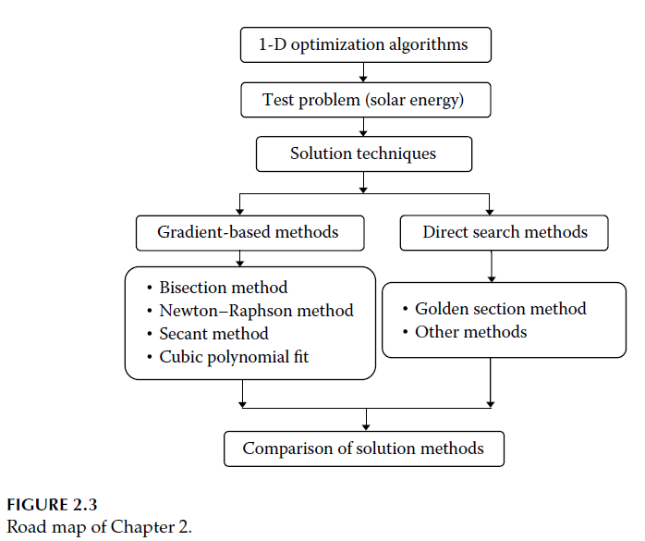
2.2 Test Problemi
2.2 Test Problem
Before starting to discuss optimization algorithms, it is necessary to define a problem on which these algorithms will be tested.
Solar energy problem: The cost of the solar energy system is given as follows:
$$U=35A+208V$$
Here, $A$represents the surface area of the collector (panel), and $V$represents the storage volume (Figure 1.19). Due to energy balance considerations, the following relationship between $A$and $V$must be satisfied:
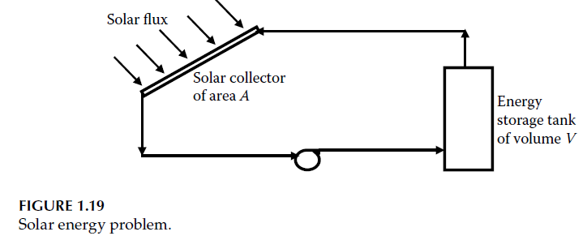
$$A\left(290-\frac{100}{V}\right)=5833.3$$
In addition, the design variable $T$(temperature) is related to $V$as follows (relationship between volume and temperature).
$$\frac{V}{T}=\frac{50}{20}$$
The variable $T$must be restricted between 40°C and 90°C (this is a bound constraint).
The objective is to minimize the cost function $U$.
Formulate this situation as an optimization problem.
In this cost minimization problem, the cost is a function of the storage volume and the collector surface area. The volume and surface area, in turn, are functions of the design variable temperature $T$.
Let us rewrite the cost function only in terms of $T$:

Relationship Between $V$and $T$
Given:
$$\frac{V}{T}=\frac{50}{20} \\ V=2.5T$$
Relationship Between $A$and $T$
Given the balance equation:
$$A\left(290 − \frac{100}{V}\right)=5833.3$$
Substitute $V=2.5T$:
$$A\left(290 − \frac{100}{2.5T}\right)=5833.3 \\ A\left(290 − \frac{40}{T}\right)=5833.3 \\ A(T)=\frac{5833.3}{290-\frac{40}{T}}$$
Eliminate $T$from the denominator:
$$A(T)=\frac{5833.3T}{290T-40}$$
Relationship Between $U$and $T$(Raw Form)
$$U=35A+208V$$
Substitute $A(T)$and $V(T)$:
$$U(T)=35\left(\frac{5833.3T}{290T-40}\right)+208(2.5T) \\ U(T)=\frac{204165.5T}{290T-40}+520T$$
4. We must decompose it into partial fractions to simplify the derivative:
This rational function is algebraically decomposed:

4.1 Convert it into a single rational function
We combine the terms so that the common denominator becomes
$290T-40$.

$$U(T)=\frac{204165.5T+520T(290T-40)}{290T-40}$$
Expand the numerator:
$$520T(290T-40)=150800T^{2}-20800T$$
$$U(T)=\frac{150800T^{2}+183365.5T}{290T-40}$$
4.2 Find the roots of the denominator (very important!)
The expression in the book is of the following form:
$$\frac{A}{T-a}+\frac{B}{T-b}+\frac{C}{T-c}$$
This means that, in the actual model, the denominator contains three linear factors.
The book provides us with the result:
$$\left(T-165.5)(T-210)(T-20\right)$$
So our function is actually in the following form:
$$U(T)=\frac{P(T)}{\left(T-165.5)(T-210)(T-20\right)}$$
4.3. Set up the partial-fraction form
General form:
$$\frac{P(T)}{\left(T-a)(T-b)(T-c\right)}=\frac{A}{T-a}+\frac{B}{T-b}+\frac{C}{T-c}$$Here:
$$\frac{P(T)}{\left(T-165.5)(T-210)(T-20\right)}=\frac{A}{T-165.5}+\frac{B}{T-210}+\frac{C}{T-20}$$
4.4. Eliminate the denominators (most critical step)
Multiply both sides by the common denominator.:
$$P(T)=A(T-210)(T-20)+B(T-165.5)(T-20)+C(T-165.5)(T-210)$$No fractions remain → a pure polynomial equation.
4.5. Cover-Up Method
The fastest method: substitute the roots of $T$.
For the coefficient $A$:
$T=165.5$yaz:
$P(165.5)=A(165.5-210)(165.5-20)$ the others are zero.
$$A=\frac{P(165.5)}{\left(165.5-210)(165.5-20\right)} \\ A=204$$For the coefficient $B$:
$T=210$:
$$B=\frac{P(210)}{\left(210-165.5)(210-20\right)} \\ B=330$$For the coefficient $C$:
$T=20$:
$$C=\frac{P(20)}{\left(20-165.5)(20-210\right)} \\ C=400$$ Result
$$U\left(T\right)=\frac{204}{T-165.5}+\frac{330}{T-210}+\frac{400}{T-20} (2.1)$$
This is only the partial-fraction form of $U(T)$. The variable $T$is constrained between 40°C and 90°C. The function $U$, as a function of $T$, is plotted in Figure 2.4. The minimum value occurs at $T^{*}=55.08$, and the minimum function value is $U^{*}=1225.166$. From the figure, it can be observed that the cost function is unimodal.
The MATLAB® code we wrote was used to plot the cost function by varying the design variable $T$from 40 to 90 with a step size of 0.01. Considering that this method can find the minimum and is quite simple, one might question why other algorithms need to be learned. However, the number of function evaluations performed in this method is
$$(90-40)/0.01=5000$$
which is quite large. In more complex problems, the function evaluation time becomes very critical, and computing the function this many times may not be practical. This situation necessitates the investigation of new algorithms that require fewer function evaluations to reach the minimum.
The output obtained when this code is executed is as follows:
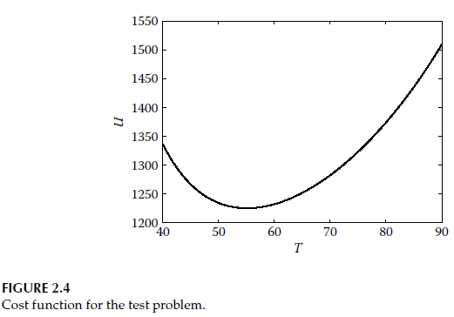
Additional note: At this stage, finding the roots of $T$in the given $U$function does not mean finding the minimum point.
Those are simply the zeros of the function and are unrelated to the minimum.
At the minimum point, the slope is zero. Using this information, we can calculate the point where the cost attains its minimum
$$\frac{dU}{dT}=0$$

Derivate rule:
$$\frac{d}{dT}\left(\frac{A}{T-a}\right)=-\frac{A}{\left(T − a)^{2}\right.}$$

Derivate
$$U^{'}(T)=-\frac{204}{\left(T − 165.5)^{2}\right.}-\frac{330}{\left(T − 210)^{2}\right.}-\frac{400}{\left(T − 20)^{2}\right.}$$
How was $T=55.08$obtained? For the minimum point:
The following equation is solved numerically:
$$U^{'}(T)=0$$
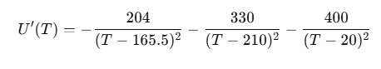
This equation:
- is not a polynomial
- has no closed-form solution
Therefore, using the Newton method or an iterative procedure:
$$T^{*}≈{55.08}^{∘}C$$
is obtained.

